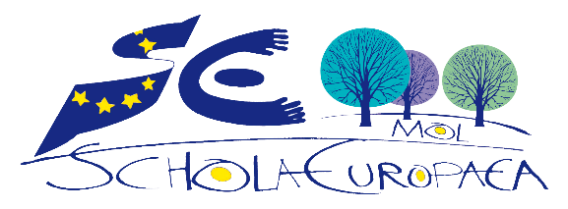
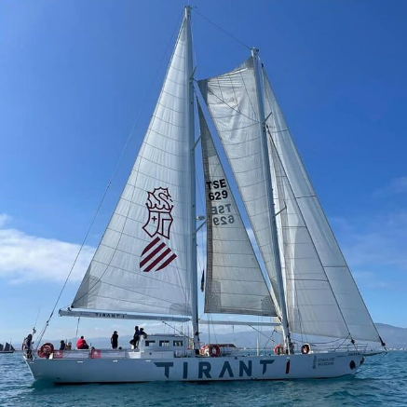

We are proud to announce our participation in the #RaiseCS project!

RAISE-CS stands for 'RAISe Education Sails through Citizen Science' and aims to make citizen science an integral part of high school curricula.

The main objective of the project is to lay the groundwork for implementing EU-wide scientific campaigns co-created by secondary schools to preserve the marine environment.

During this academic year S5 students will learn the fundamental aspects of large-scale environmental science studies. They will carry out activities related to microplastic pollution research while acquiring key competences needed for personal fulfilment, lifelong learning and development.

The Flagship activity will be a science week in Spain in March 2023. With the support of scientists from the Ayam Sailing Association, the EU Commission's Joint Research Centre and the University of Ghent, our students will learn to assess microplastics in rivers and on the sea surface.

For more information 👉 https://www.erasmusmaris.eu/

